PROJECT REPORT

AGRIEDGE
Salesforce-Driven Order Management System
Submitted by
NANDHINI S - 24ADR088
Department : Artificial Intelligence and Data Science
Institution : Kongu Engineering College

ABSTRACT

- AgriEdge Or-Mange Ltd is an agriculture and food-production organization that handles products such as seeds, fertilizers, harvested crops, and processed food. Its order-management activities require accurate records, timely status updates, and coordination between order processing and shipment operations. This project develops a Salesforce-based Order Management System concept to organize order information and automate selected routine actions.
- The current project implementation focuses on order-related Salesforce objects and Apex components. The codebase includes logic for creating follow-up Tasks, updating order statuses, calculating order totals from order items, handling order-related email processing, supporting shipment-record creation, and assisting trigger execution. Apex test methods are used to verify important business rules.
- The broader design also considers inventory visibility, access control, validation, reporting, and dashboards. These broader features should be marked as completed only if they have actually been configured and tested in the Salesforce org. The system provides a practical base that can be extended to cover more of the organization's order and supply-chain requirements.

USER STORY

The order team at AgriEdge Or-Mange Ltd needs a reliable way to create orders and follow their progress. Order executives should be able to store order details, connect relevant order items, and see status changes. When an order is created, the system should help staff remember follow-up actions by creating a Task. Order totals should be calculated from item quantities and unit prices, and eligible orders should be linked to shipment records.
Managers and administrators need an organized view of business records and must be able to control access according to each user's responsibilities. Inventory monitoring, customer self-service, and comprehensive management dashboards are desirable extensions of the system.
User Role | User Story | Value
Order Executive | As an order executive, I want to record an order and its items in Salesforce so that order information is kept together. | Centralized order details.
Order Executive | As an order executive, I want a follow-up Task for a new order so that a required next step is not overlooked. | Better follow-up.
Operations User | As an operations user, I want status and total values to follow defined rules. | More consistent records.
Shipment Coordinator | As a shipment coordinator, I want shipment records associated with the relevant order. | Improved traceability.
Administrator | As an administrator, I want to control user permissions. | Safer access to records.
Manager | As a manager, I want to review order activity in reports. | Easier monitoring, after reports are configured.

1. INTRODUCTION

1.1 Project Overview

- AgriEdge Or-Mange Ltd operates in agriculture and food production. Its product range includes seeds, fertilizers, harvested crops, and processed food products. In this type of business, order records need to be accurate and accessible so that employees can coordinate processing and shipment activities.
- The AgriEdge Order Management System uses Salesforce as the platform for storing related records and applying business logic. The project uses custom order-related objects and Apex classes to automate selected activities. The principal components are OrderTaskCreator, OrderStatusUpdater, OrderTotalUpdater, OrderEmailSender, AgriEdgeOrderShipmentHelper, AgriEdgeOrderTriggerHelper, and AgriEdgeOrderTests.
- The project aims to reduce repeated manual actions and establish a structure that can later support inventory tracking, approvals, customer-service processes, and management reporting.

1.2 Purpose
- Keep order and order-item information organized in Salesforce.
- Create Tasks for order follow-up.
- Apply defined order-status rules.
- Calculate order totals using related order-item records.
- Support shipment creation for eligible orders.
- Implement and test order-related email logic.
- Validate the Apex behavior through unit tests.
- Provide a foundation for inventory monitoring and business reporting.

2. IDEATION PHASE

2.1 Problem Statement
When order details and follow-up actions are managed through disconnected records or manual notes, employees may need to repeat work and verify information several times. This can lead to missed tasks, incorrect totals, inconsistent statuses, and poor visibility of shipment progress. AgriEdge needs a central record system with automation that applies predictable rules to common order activities.
Problem / User | Need | Challenge | Possible Effect
Order Executive | Create and follow orders | Manual updates and follow-up reminders | Delays or missed actions
Operations Staff | Maintain accurate totals and statuses | Repeated calculation or status entry | Inconsistent records
Shipment Coordinator | Relate shipments to orders | Shipment information may be separate | Harder tracking
Manager | Review operational performance | No summary unless information is organized | Slower decisions
Administrator | Protect business records | Different users need different permissions | Excessive or insufficient access

2.2 Empathy Map Canvas

Persona: Order Executive
- Wants to process each order correctly and avoid missing follow-up steps.
- Receives requests for status updates from customers and internal staff.
- Order details, item values, task lists, and shipment information.
- Creates records, checks status, follows up on tasks, and coordinates with colleagues.
- Repeated data entry, unclear follow-up ownership, and inconsistent updates.
- A single place to review an order and automate routine actions.

2.3 Brainstorming and Idea Prioritization

Step 1: Ideas Considered
- Use a shared spreadsheet to record orders and follow-up notes.
- Build a standalone web application for order entry and tracking.
- Extend an existing enterprise resource planning system.
- Use Salesforce custom objects and relationships to organize order records.
- Use Apex to create Tasks and apply status and total-calculation rules.
- Link shipment records to orders and make status easier to inspect.
- Add Salesforce reports and dashboards after the required data is available.

Step 2: Grouping of Ideas

Group | Options | Evaluation
Manual tracking | Spreadsheet and manual reminders | Simple to begin, but ongoing accuracy depends on users.
Custom-built application | Standalone order portal | Flexible but requires separate implementation and maintenance.
Existing enterprise system | ERP extension | Potentially broad coverage, but setup and integration may be complex.
Salesforce platform | Custom objects, Apex, permissions, and reports | Fits the current project and supports incremental development.

Step 3: Prioritization

Idea | Impact | Feasibility | Cost / Effort | Reason
Spreadsheet tracking | Medium | High | Low initial effort | Easy to start but limited automation.
Standalone portal | High | Medium | Medium to high | Requires application development.
ERP extension | High | Medium-Low | High | May involve complex integration.
Salesforce OMS | High | High for the current prototype | Depends on org and licensing | Uses platform features and Apex already included in the project.

3. REQUIREMENT ANALYSIS PHASE

3.1 Customer Journey Map

Stage | Action | Potential Issue | System Response | Outcome
1. Order preparation | Staff gathers customer and product details. | Details may be incomplete. | Use structured fields and required information. | More consistent input.
2. Order creation | Staff creates the order record. | Manual entry errors. | Store the order in the custom order object. | Central order record.
3. Follow-up | Staff identifies the next required action. | Follow-up may be forgotten. | Apex creates Task records for the supplied order IDs. | Recorded follow-up activity.
4. Status update | Order status changes as work proceeds. | Status changes may be inconsistent. | Status class and trigger apply configured rules. | Predictable status handling.
5. Total calculation | Order items are attached to the order. | Manual total calculation can be wrong. | Apex calculates total from item values. | Consistent calculated total.
6. Shipment processing | A shipment record is needed. | Order and shipment may be hard to trace together. | Helper logic creates a linked shipment under its conditions. | Related shipment record.
7. Review | Managers review order performance. | Summary views may be missing. | Reports and dashboards can be configured. | Improved visibility if implemented.

3.2 Solution Requirements

3.2.1 Functional Requirements

ID | Requirement | Description | Implementation Note
FR-1 | Order Records | Create and maintain order information. | Custom order object is part of the project.
FR-2 | Order Items | Store item quantity and unit price against an order. | Confirm relationship field API name in Object Manager.
FR-3 | Task Creation | Create follow-up tasks associated with orders. | OrderTaskCreator is provided.
FR-4 | Status Processing | Update status based on business rules. | Verify OrderStatusUpdater and trigger results.
FR-5 | Total Calculation | Compute totals from associated items. | Verify OrderTotalUpdater tests.
FR-6 | Email Logic | Handle order-related email activity. | Check actual sendEmail behavior and test assertions.
FR-7 | Shipment Processing | Create shipment records for qualifying orders. | Verify helper conditions and duplicate handling.
FR-8 | User Access | Limit data access by responsibility. | Document only configured security settings.
FR-9 | Inventory | Monitor quantities and identify low-stock products. | Additional objects/logic may be required.
FR-10 | Reports | Summarize orders, shipments, and stock. | Requires report types, reports, and dashboards.

3.2.2 Non-Functional Requirements

ID | Requirement | Description
NFR-1 | Security | Apply object, record, and field access controls based on user duties.
NFR-2 | Usability | Use understandable page layouts, tabs, and related lists.
NFR-3 | Performance | Avoid unnecessary queries and support multiple records in Apex where possible.
NFR-4 | Maintainability | Keep business logic in clearly named classes and helpers.
NFR-5 | Reliability | Run tests for successful processing and edge cases.
NFR-6 | Accuracy | Validate relationships, quantities, statuses, and calculated values.

3.3 Data Flow Diagram

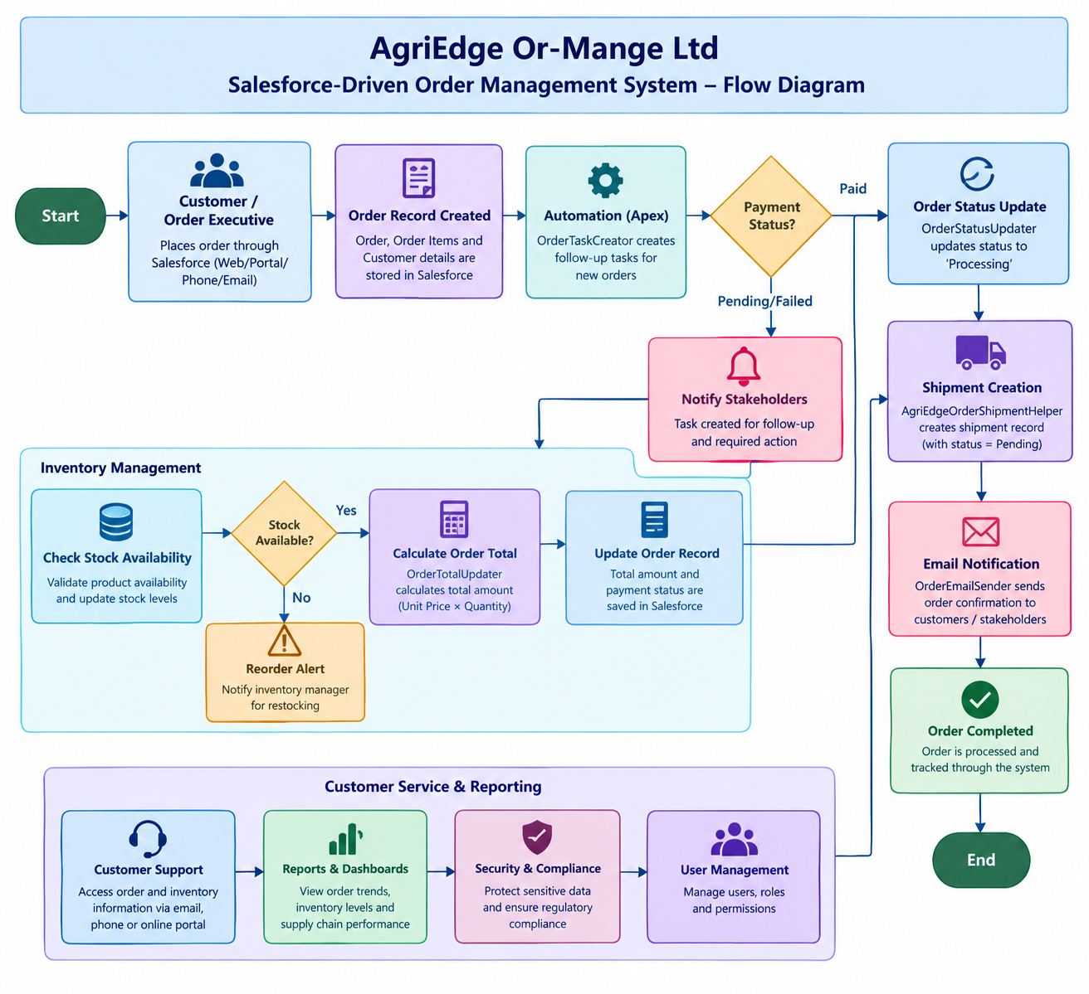

4. PROJECT DESIGN PHASE

4.1 Problem–Solution Fit

Problem | Designed Response | Salesforce Feature
Order data needs a consistent home. | Store each order as a Salesforce record. | Custom object and fields.
Follow-up actions can be missed. | Create a related Task automatically. | Task object and Apex.
Statuses need consistent rules. | Apply status updates from business logic. | Apex and trigger.
Totals need accurate calculation. | Aggregate the order-item values. | SOQL and Apex.
Shipment records need order context. | Relate a shipment to its order. | Custom object relationship.
Access varies by job role. | Configure access based on responsibility. | Profiles, roles, permission sets, sharing, and field security.
Management needs summary information. | Create reports and dashboards. | Salesforce reporting tools, if configured.

4.2 Proposed Solution

Parameter | Description
Current challenge | Order-related activities may require repeated manual checks and updates.
Proposed system | A Salesforce OMS using custom records and Apex logic for selected processes.
Main technical approach | Custom objects and relationships, Apex classes, trigger logic, and Apex tests.
Expected value | More consistent order records and reduced repetitive effort.
Expansion path | Inventory alerts, approval processes, customer access, integrations, and advanced analytics.

4.3 Solution Architecture
The system can be represented as five connected layers:
Presentation layer: Salesforce Lightning pages, tabs, record views, and related lists.
Business logic layer: OrderTaskCreator, OrderStatusUpdater, OrderTotalUpdater, OrderEmailSender, and AgriEdgeOrderShipmentHelper.
Trigger-support layer: Order trigger and AgriEdgeOrderTriggerHelper, based on the configured trigger events.
Data layer: Order, Order Item, Shipment, Task, User, and relevant customer records.
Security and reporting layer: Configured profiles, permission sets, sharing controls, reports, and dashboards.
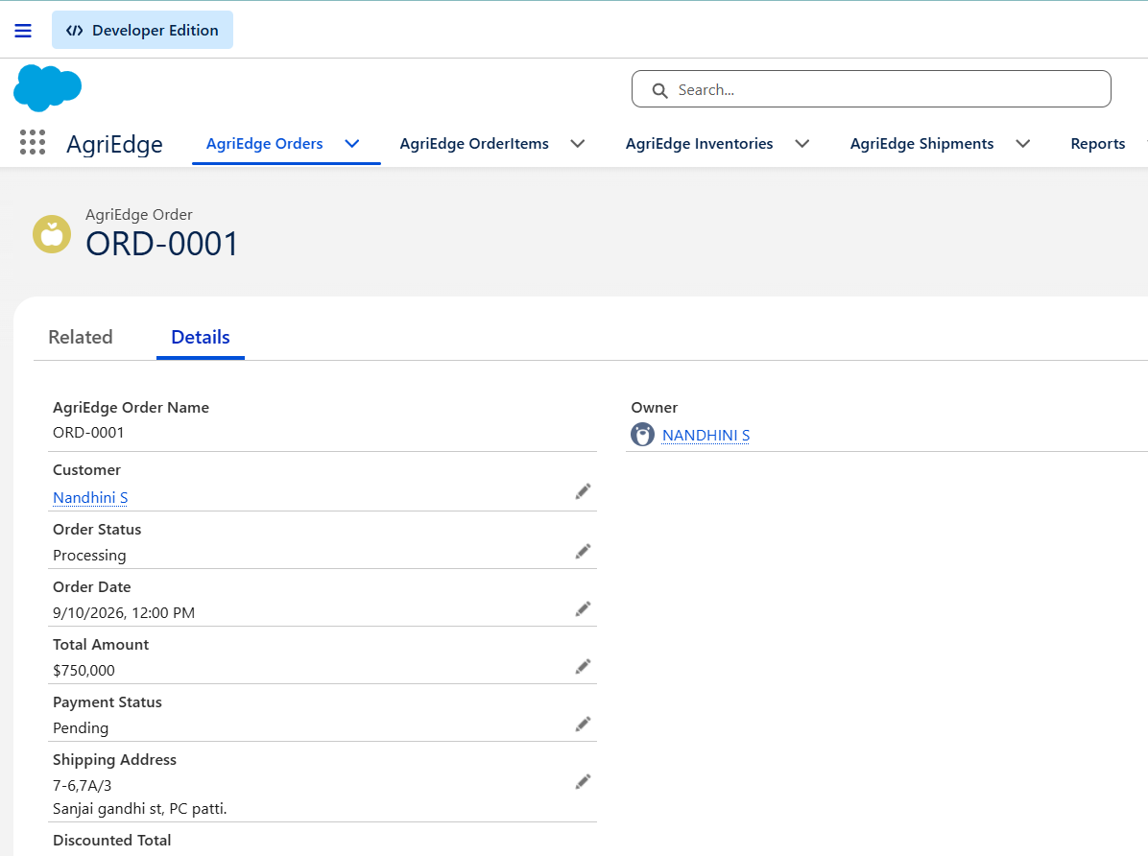

5. PROJECT PLANNING AND SCHEDULING

5.1 Planning Method
An iterative approach is suitable for this project. The work can be divided into small phases so that the data model is prepared first, business logic is implemented next, and the complete flow is tested before the final report is prepared. At each phase, defects are recorded and corrected.

5.2 Proposed Sprint Schedule

Sprint | Activity | Deliverable | Priority
1 | Confirm requirements and Salesforce setup. | Org and implementation plan. | High
2 | Create objects, fields, and relationships. | Order data model. | High
3 | Develop Apex classes for tasks, status, and totals. | Core order logic. | High
4 | Configure trigger and shipment/email behavior. | Integrated order processing. | High
5 | Create and run Apex tests. | Test outcomes and defect fixes. | High
6 | Review interface, add reporting if available, and prepare documentation. | Report and evidence screenshots. | Medium

5.3 Roles and Responsibilities

Role | Responsibility
Administrator / Developer | Configure Salesforce objects, fields, tabs, and access settings.
Apex Developer | Implement and maintain classes, triggers, and helper logic.
Tester | Run tests, check assertions, and record failures.
Order Executive (business role) | Enter and review order details.
Manager (business role) | Review order and shipment information and business summaries.

6. PROJECT DEVELOPMENT PHASE

Milestone 1: Salesforce Developer Account Creation
A free Salesforce Developer Edition org is the working environment where the entire AgriEdge Order Management System is built, tested, and demonstrated. It provides the platform required to configure objects, automation, security, reports, and dashboards.
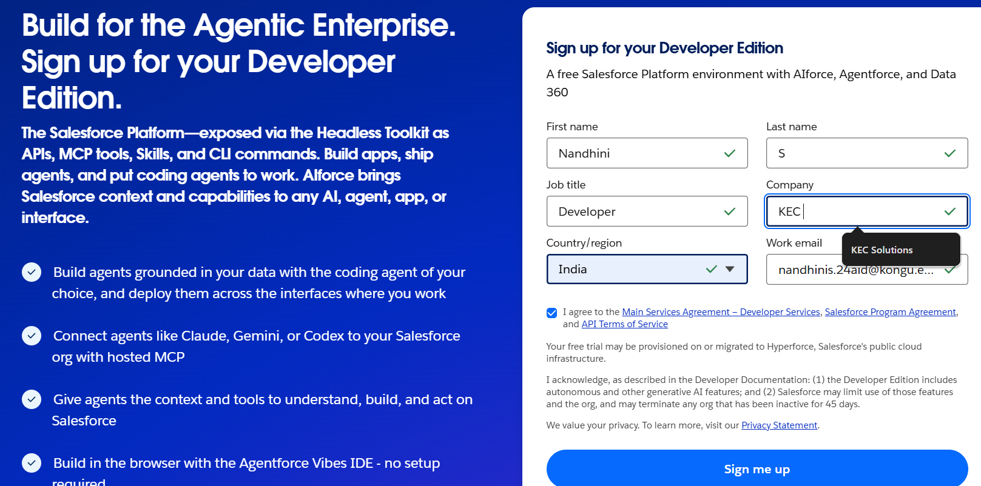

Milestone 2: Custom Object Creation
Custom objects store the main business information required by AgriEdge. The system uses objects such as Customer, Product, Inventory, Order, Payment, and Delivery to manage the complete order lifecycle.
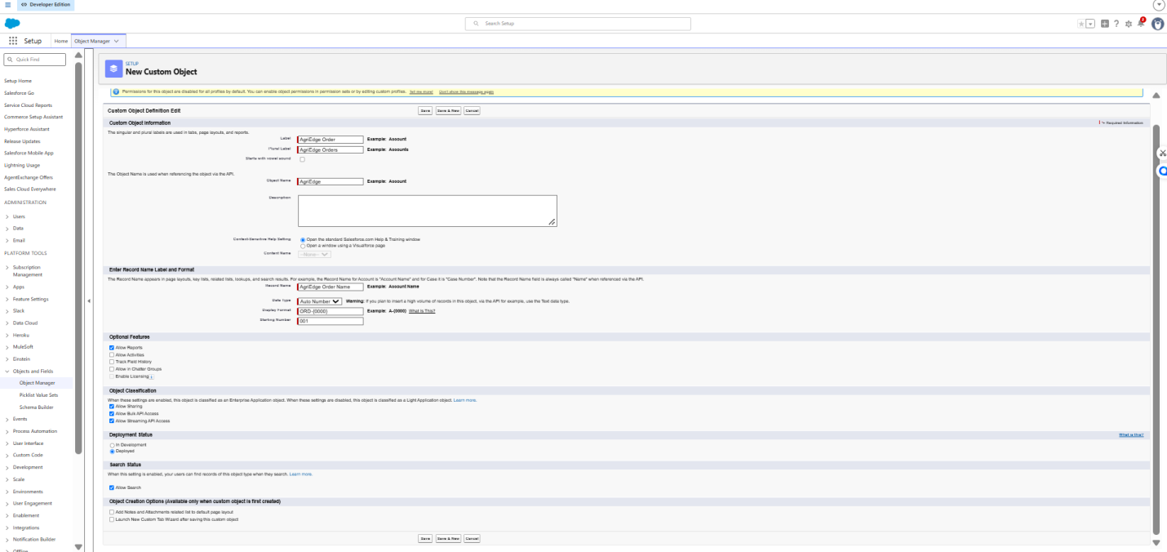

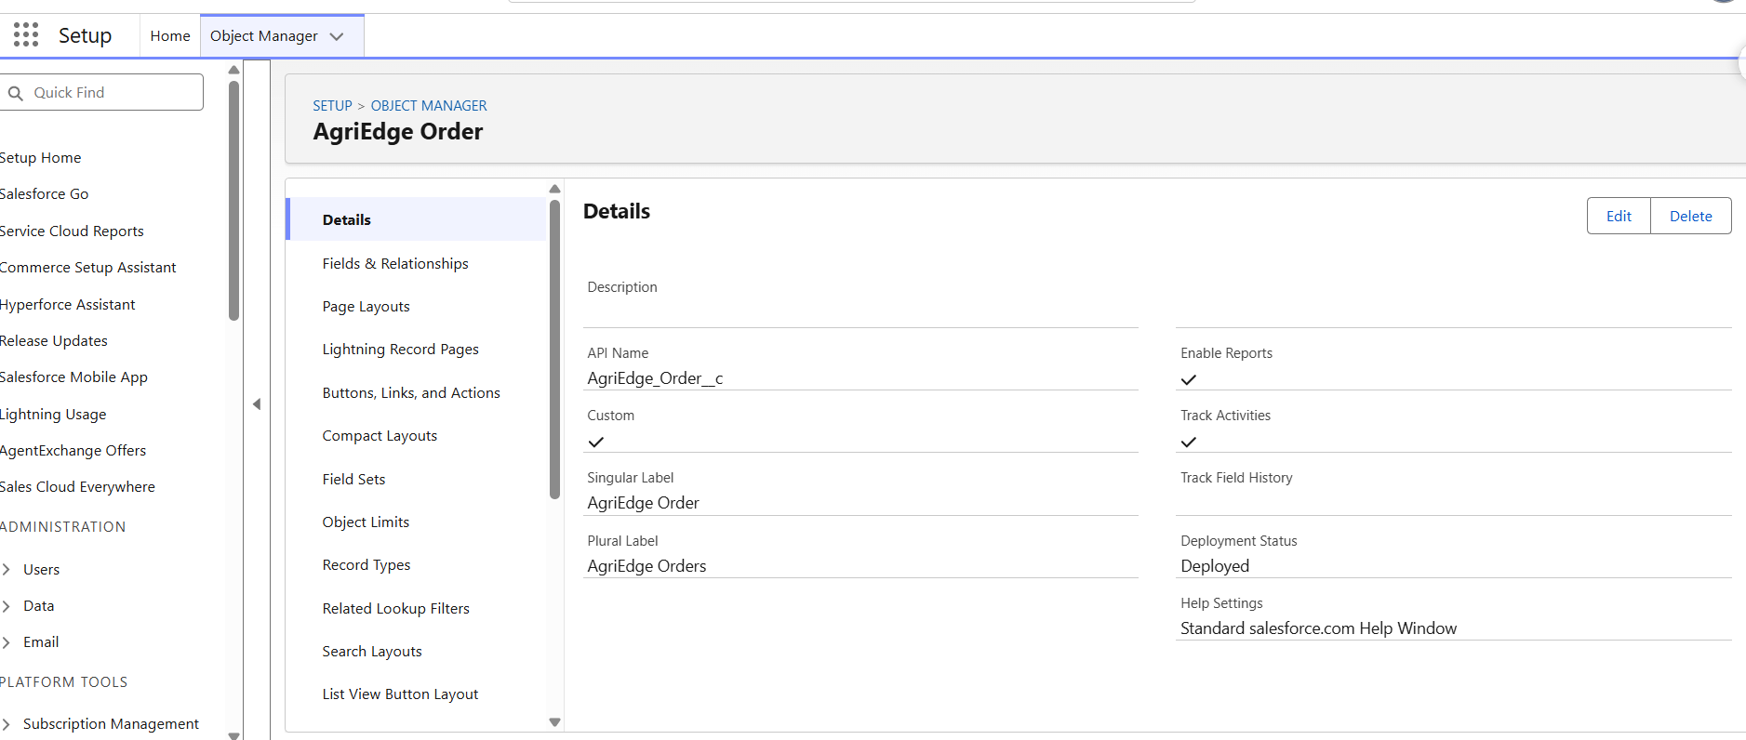

Milestone 3: Tabs Creation
Tabs provide navigation shortcuts to access records stored in each object. Dedicated tabs allow users to easily move between customers, products, inventory, orders, payments, and deliveries.
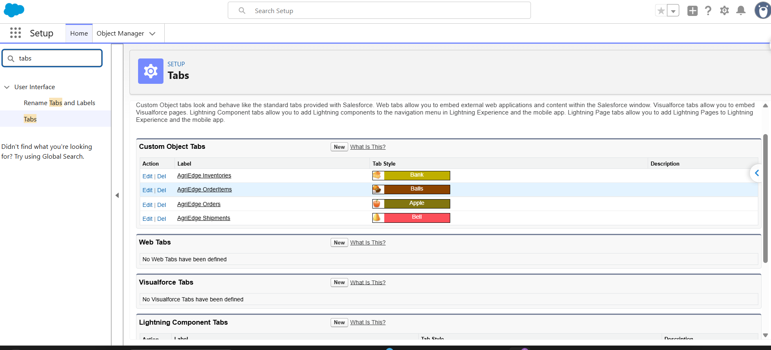

Milestone 4: Lightning App Creation
A Lightning App groups related tabs and features into a single workspace. The AgriEdge application provides users with a centralized interface for managing customers, products, orders, inventory, and related operations.
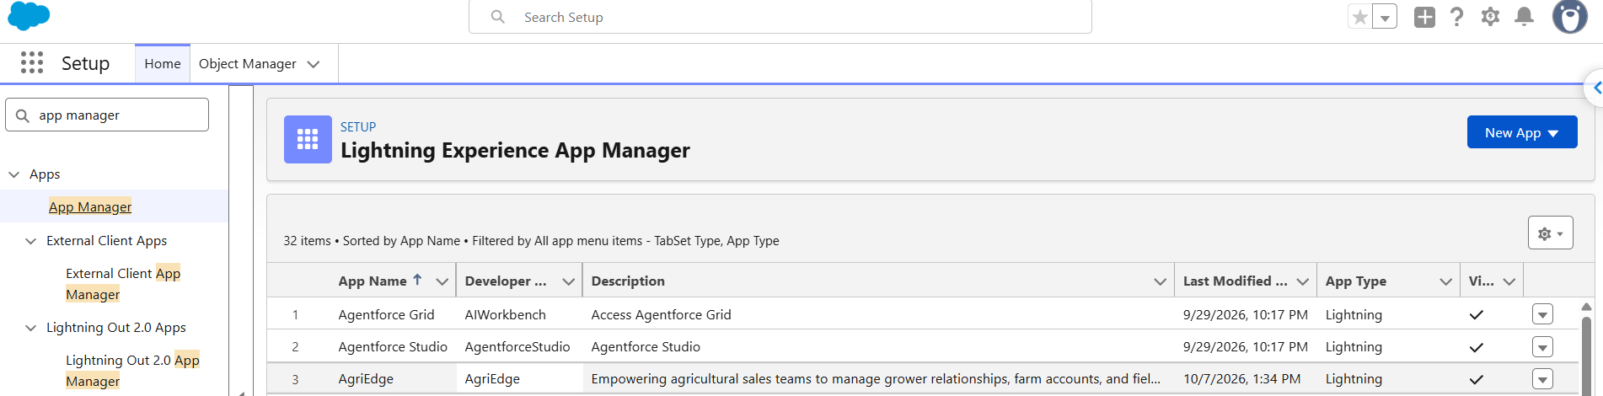

Milestone 5: Fields Creation
Fields store individual pieces of information within each object. They capture customer details, product information, inventory quantities, order status, payment details, and delivery information accurately.
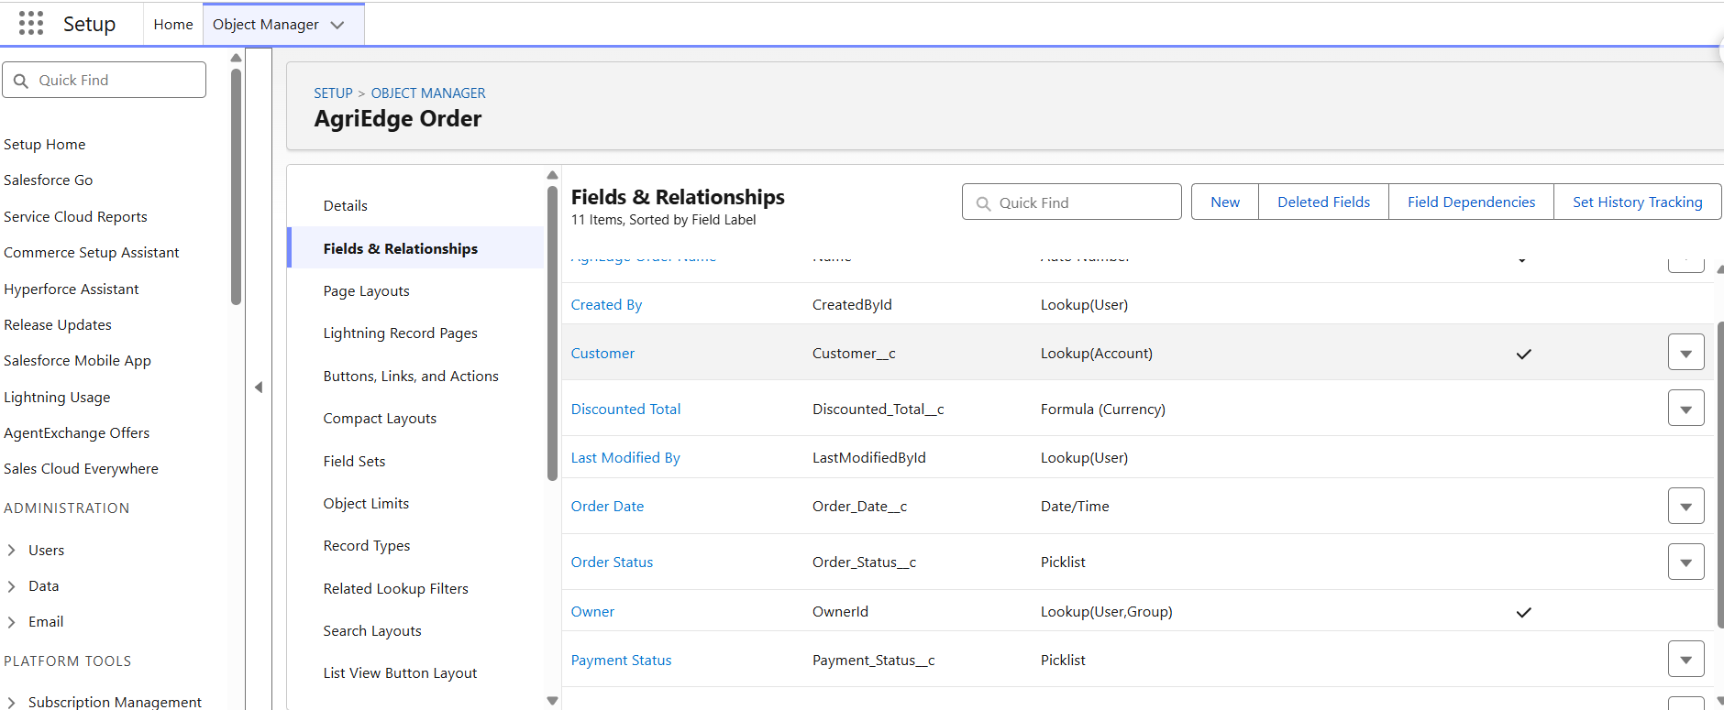

Milestone 6: Data Management – Field Creation & Field Types
Fields store individual pieces of information in each AgriEdge object. Different field types are selected based on the type of data required, such as customer details, product information, order status, inventory quantity, payment, and delivery information.
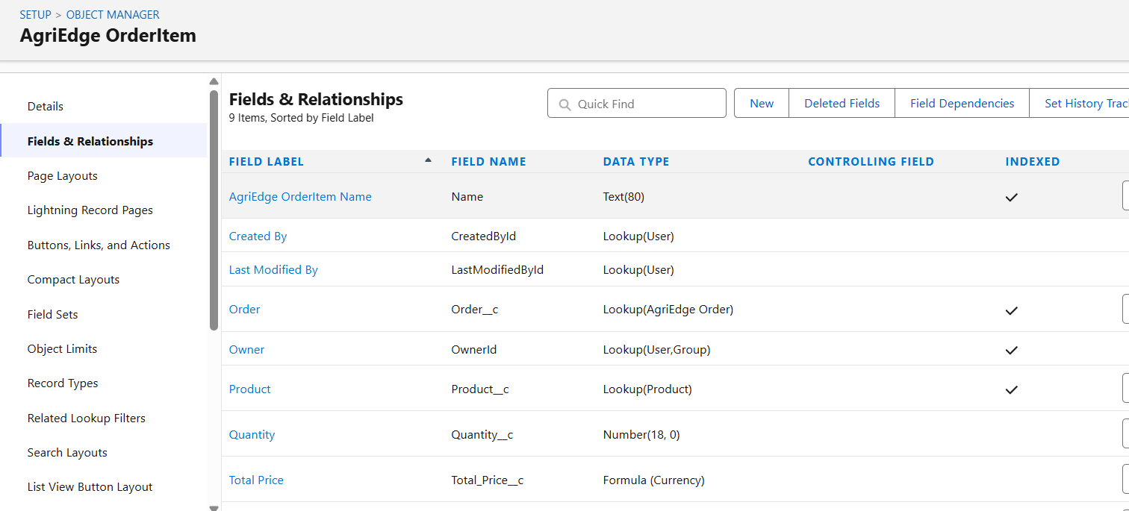

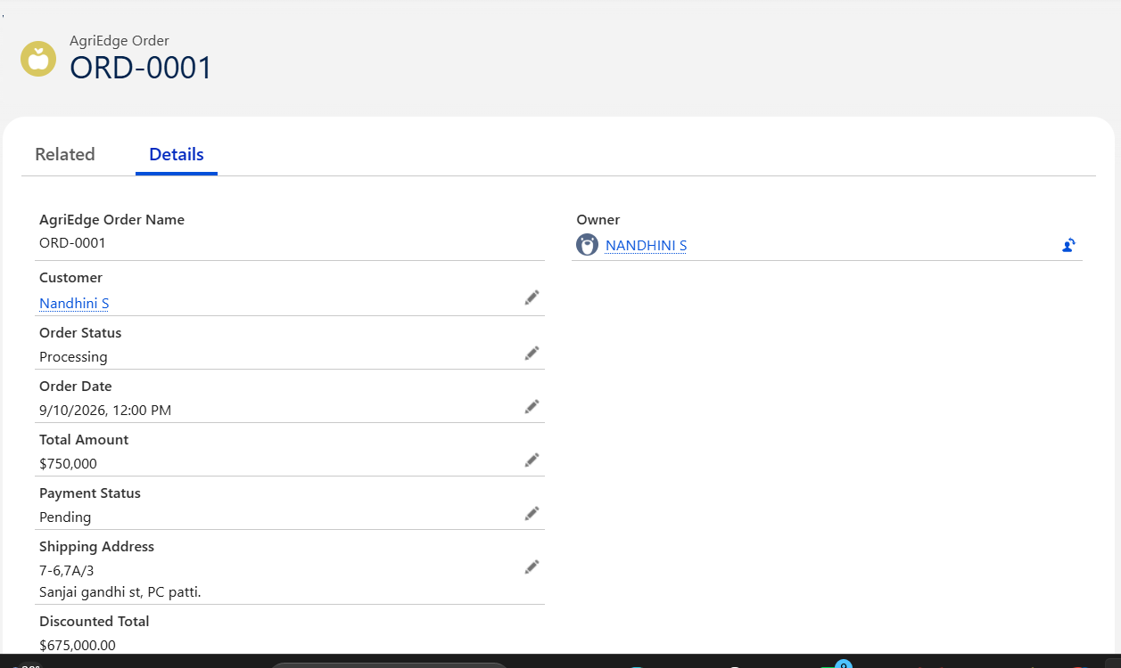

Milestone 7: Data Security – Roles
Roles control the level of record access for different users in the AgriEdge system. They help ensure that users can access the customer, order, inventory, and business records required for their responsibilities.
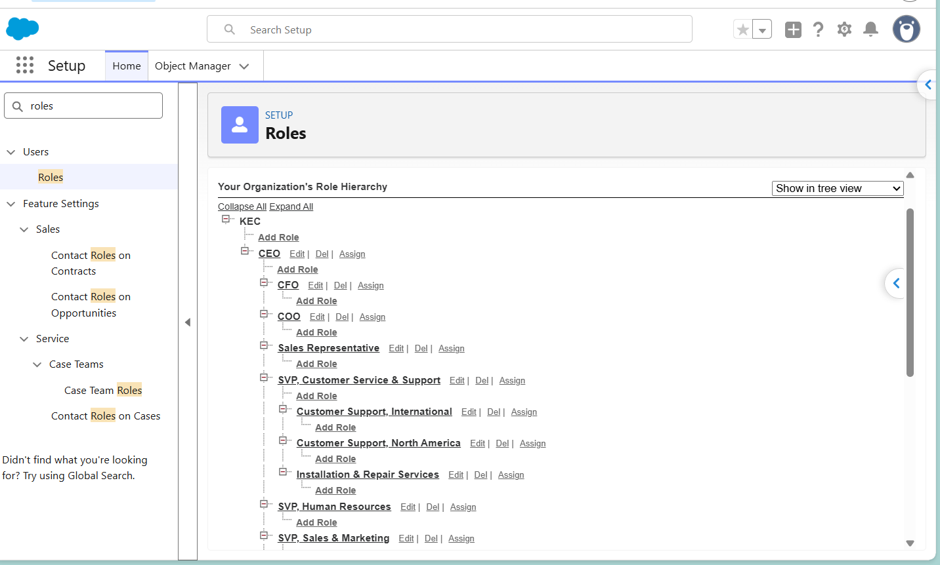

Milestone 8: Data Security – Profiles
Profiles define the permissions and access levels of users in the AgriEdge system. They control which objects and features users can view, create, edit, or delete based on their responsibilities.
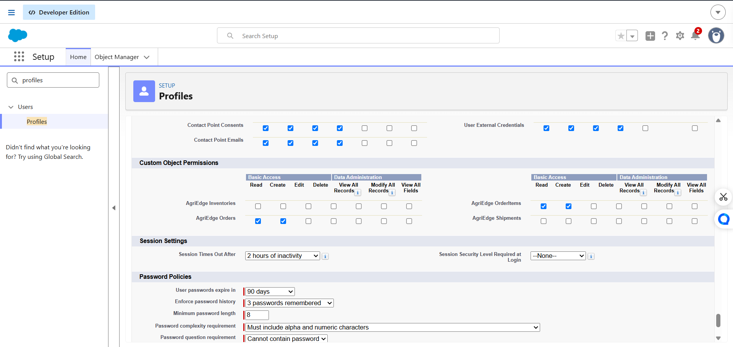

Milestone 9: Data Security – Users
Users are individual accounts created for people who access the AgriEdge system. Each user is assigned an appropriate role and profile to control access to customers, orders, inventory, and other business information.
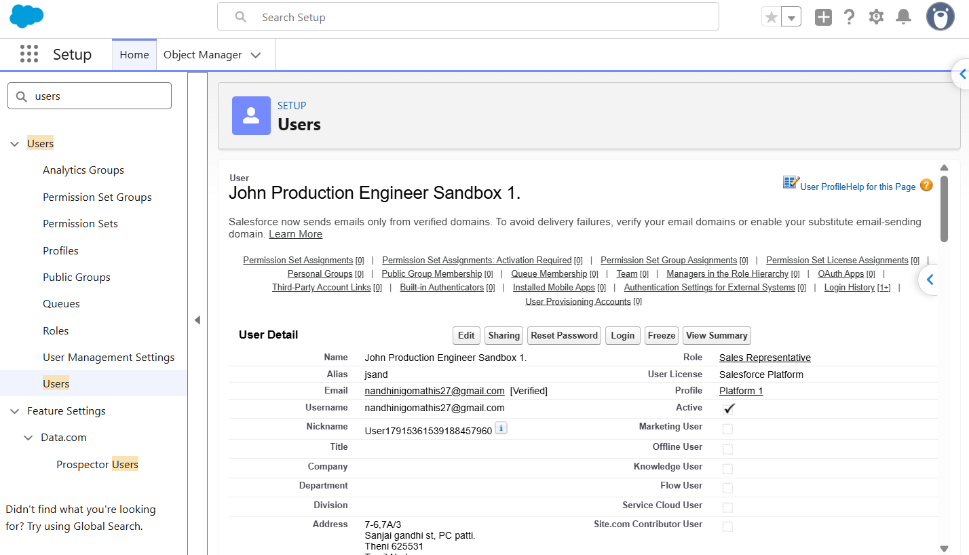
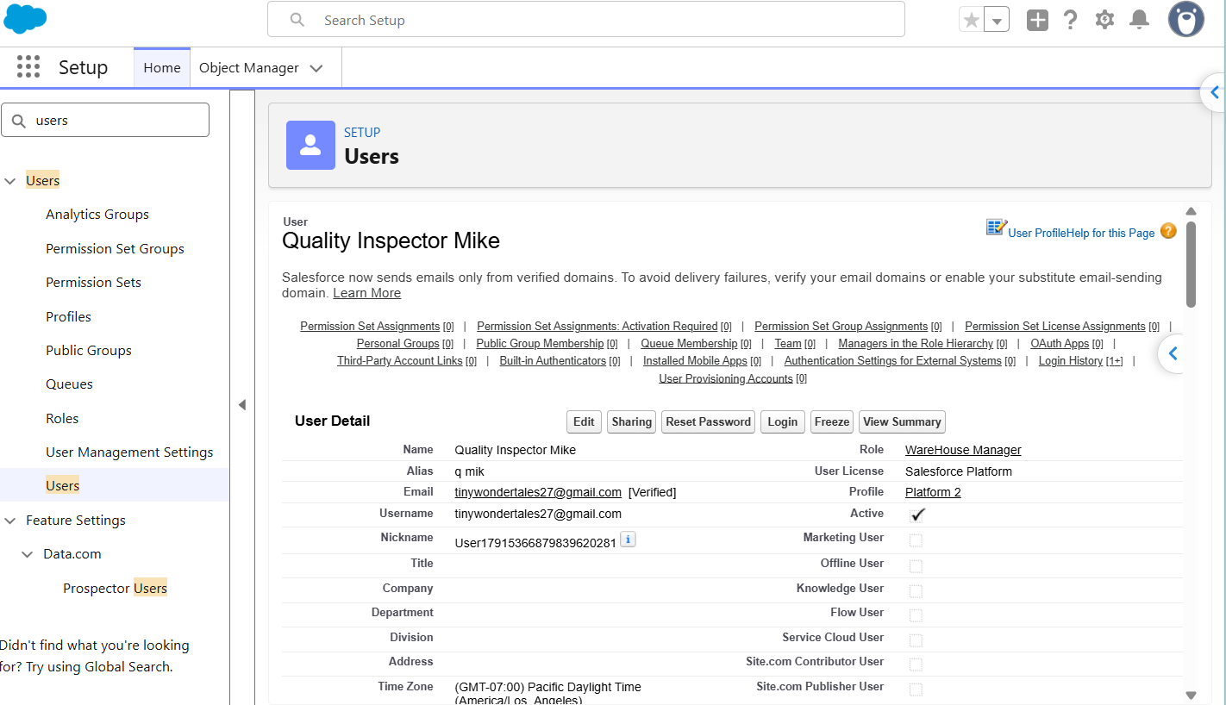

Milestone 10: Data Security – Field-Level Access
Field-level access controls which users can view or edit specific fields in the AgriEdge system. It protects sensitive information by allowing access only to users who require it for their responsibilities.
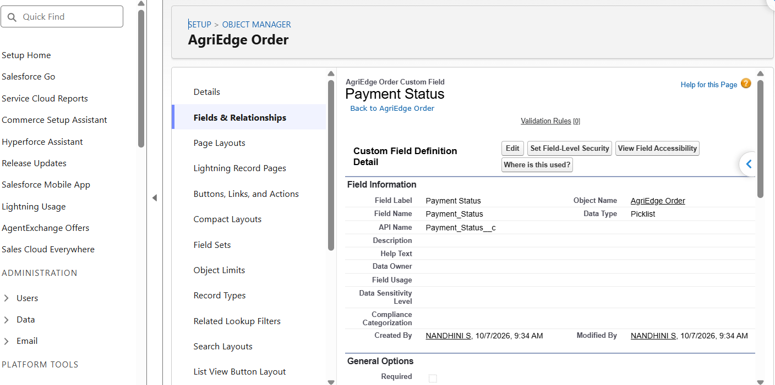

Milestone 11: Apex Class, Triggers & Testing
Apex Classes and Triggers are used to implement custom business logic in the AgriEdge system. Apex Test Classes verify that the implemented logic works correctly and helps ensure reliable order and inventory processing.
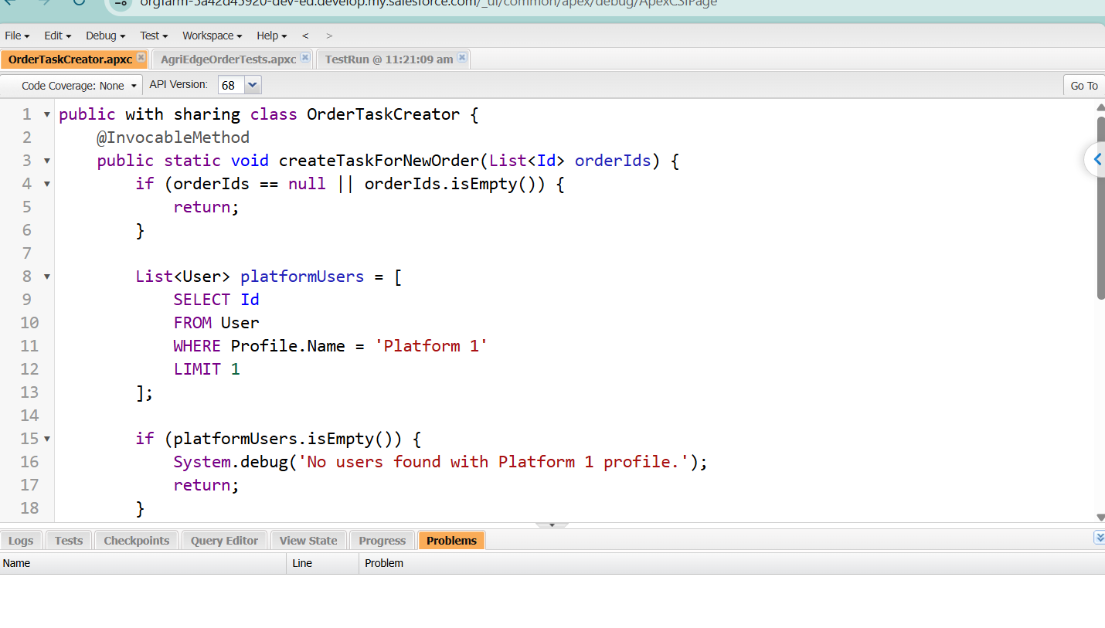
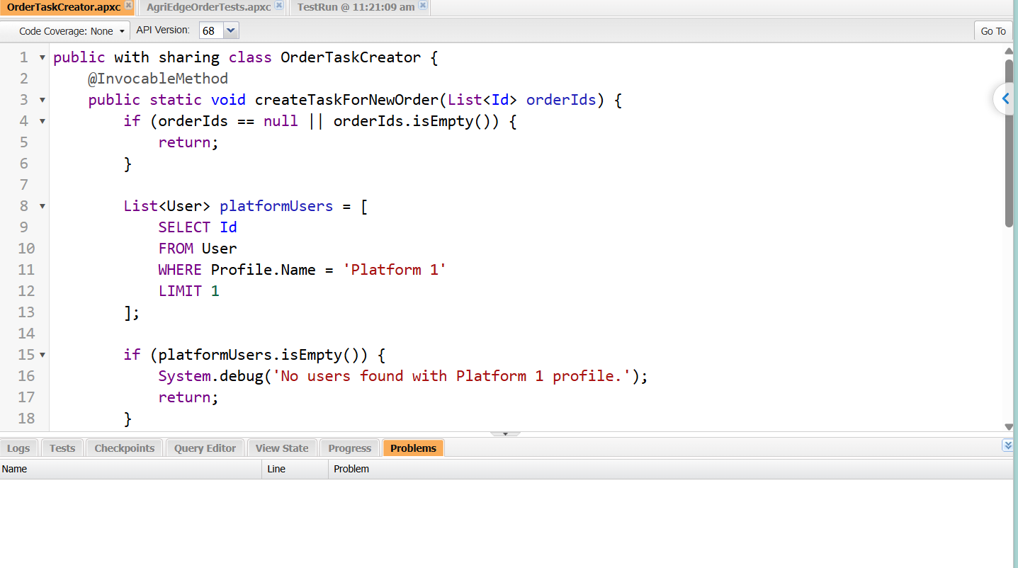
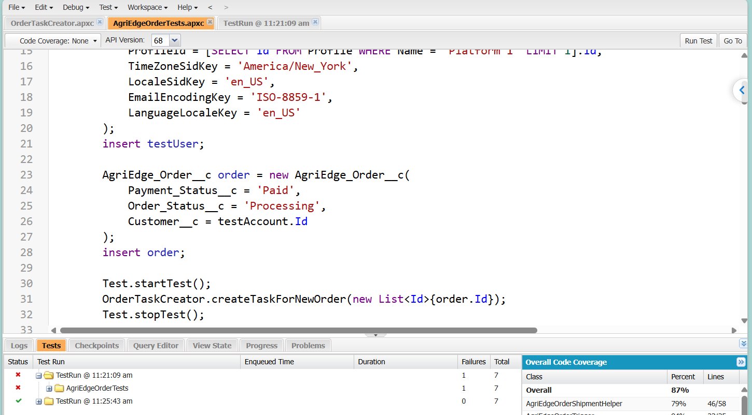

Milestone 12: Automation
Automation uses Salesforce Flows and automated actions to reduce manual work in order processing. It automatically updates order information, manages order status, and performs required actions when order records are created or modified.
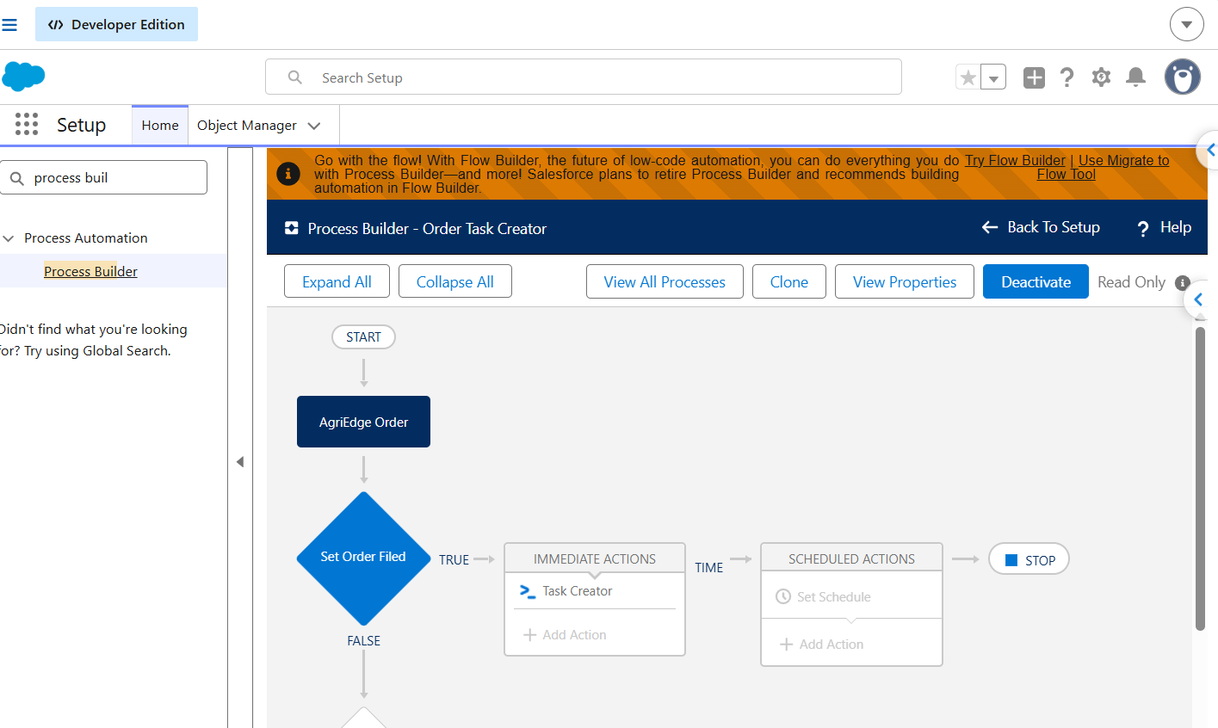

7. CONCLUSION

The AgriEdge Order Management System applies Salesforce data modelling and Apex development to selected order-management activities. Its core logic supports follow-up Task creation, order-status processing, order-total calculation, email-related processing, shipment-record handling, and trigger support. These features provide a structured foundation for handling order information and reducing repetitive manual work.
The project also highlights the importance of validating data relationships, writing reliable Apex tests, and configuring access controls. Additional work can extend the solution with inventory monitoring, automated approvals, customer-facing order tracking, reports, dashboards, and integrations with payment or logistics services.

7.1 Outcomes and Benefits
- Order-related records can be stored and linked in Salesforce.
- Follow-up Tasks can be generated by Apex according to the configured user query.
- Order status and total calculations can follow reusable business rules.
- Shipment records can be connected to qualifying orders.
- The system can be extended with additional inventory and reporting capabilities.

